SPAM FILTER

Mohamed ahmed 3116

Naive Bayes classifiers, a family of classifiers that are based on the popular Bayes’ probability theorem, are known for creating simple yet well performing models, especially in the fields of document classification and disease prediction.

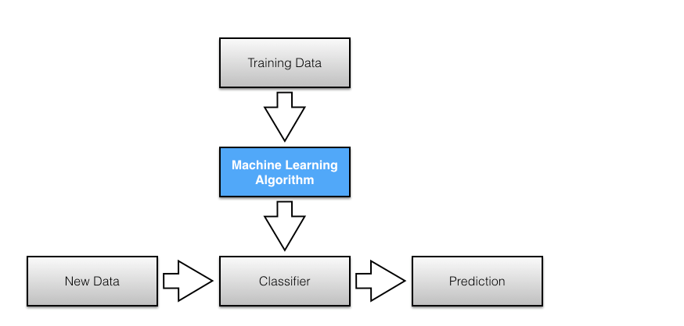

We implement classifier class and inherit naïve-classifeier from it.

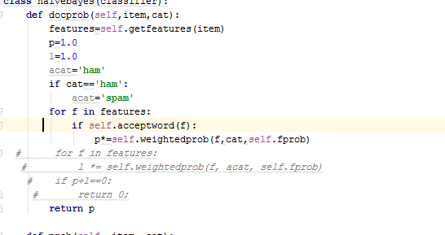

We calc probability of category by function prob

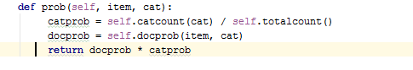

Training :

We read 3000 samples of emails from file

Preprocessing it and generate features to enable classification

Testing:

Testing 1000 samples of emails from files to spam or ham

And we can use threshold to output “unknown” also.

Output:

